 | Main topic | Companion project
Autumn 1 | Big Wide World: What’s it like where we live?
Autumn 1 | Me and my community  (titled Superheroes)  Focus on our school, building friendships, brief coverage of people who help us)  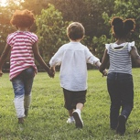 | Build it up?  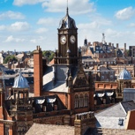
Autumn 2 | Big Wide World: Celebrations in our community and beyond
Autumn 2 |  | 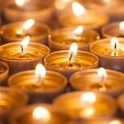  Sparkle and shine
Spring 1 | BWW – stories from around the world
Spring 1 | Once upon a time  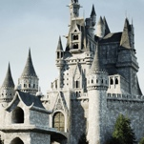 | Lunar New Year
Spring 2 | BWW – world festivals
Spring 2 | Starry Night   | 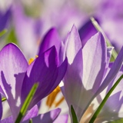  Signs of spring, inc Easter and Holi, plus elements of ‘Let’s Grow’
Summer 1 | BWW – different environments
Summer 1 | Dangerous Dinosaurs  
Summer 2 | BWW – recap/reinforce
Summer 2 | Puppets and pop-ups | 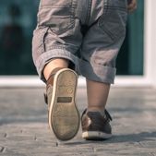  Moving On

