Term |  |  | Autumn 1 |  |  |  |  |  |  |  |  |  | Autumn 2 |  |  |  |  |  |  |  |  |  |  | Apring 1 |  |  |  |  |  |  |  |  | Spring 2 |  |  |  |  |  |  | Summer 1 |  |  |  |  | Summer 2
Murphy Class | Driver project |  | 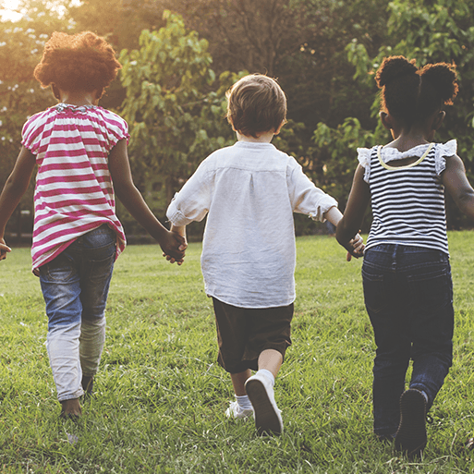  We are Superheroes |  |  |  |  |  |  |  |  |  |  |  |  |  |  Sparkle and Shine |  |  |  |  |  |  |   Starry Night |  |  |  |  |  |  |  | 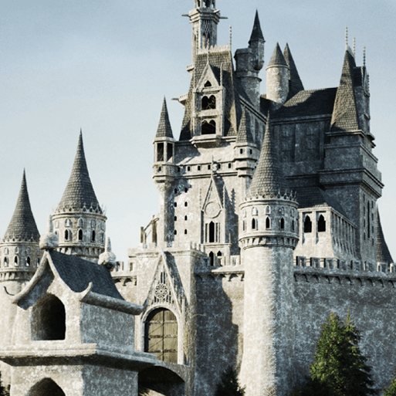  Once Upon a Time |  |  |  |  |  |  |  | 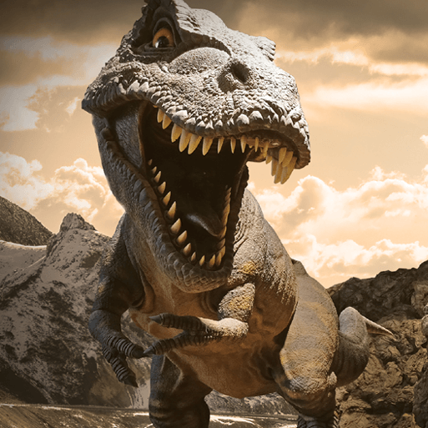  Dangerous Dinosaurs |  |  |  |  |  |  |  |  |  |  |   Big Wide World
Murphy Class | Mini project |  | Exploring Autumn |  |  |  |  |  |  |  |  |  |  |  |  |  | Exploring Autumn |  |  |  |  |  |  | Winter Wonderland |  |  |  |  |  |  |  | Puppets and Pop Ups/ Signs of Spring |  |  |  |  |  |  |  | Marvellous Machines |  |  |  |  |  |  |  |  |  |  | Marvellous Machine/ Moving On
Main theme |  |  |  |  | Geography |  |  |  |  |  |  |  |  | History |  |  |  |  |  |  |  |  |  |  |  | History |  |  |  |  |  |  |  | History |  |  |  |  |  |  |  | Geography |  |  |  |  | Geography
KS1 Cycle A | Driver project |  |  |  |   Our Wonderful World |  |  |  |  |  |  |  |  |   Memory Box |  |  |  |  |  |  |  |  |  |  |  | 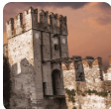  Towers, Tunnels and Turrets |  |  |  |  |  |  |  | 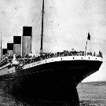  Titanic Tragedy |  |  |  |  |  |  |  | 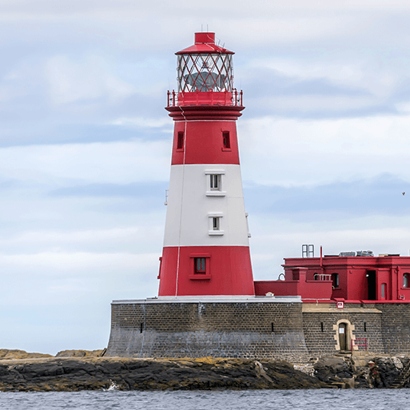  Coastlines |  |  |  |  | 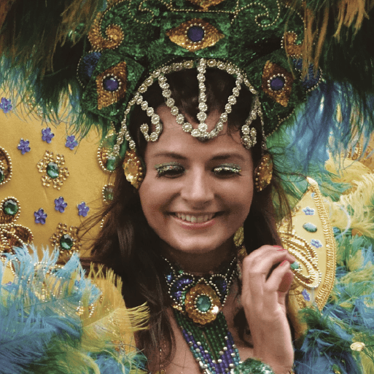  Rio da Vida
KS1 Cycle A | English pack genres
KS1 Cycle A | Book study
KS1 Cycle A | Subject-specific projects | Geog  Science |  |  | Everyday Materials |  |  |  |  |  |  |  |  | Human senses |  |  |  |  |  |  |  |  |  |  |  | Seasonal changes |  |  |  |  |  |  |  |  |  |  |  |  |  |  |  | Plant parts |  |  |  |  | Animal parts
KS1 Cycle A | Subject-specific projects | Art |  |  |  |  |  |  |  |  |  |  |  |  |  |  |  | Funny faces and fabulous features |  |  |  |  |  |  |  | Rain and sunrays |  |  |  |  |  |  |  |  |  |  |  |  |  |  |  |  |  |  |  |  | Still Life
KS1 Cycle A | Subject-specific projects | DT |  |  | Shade and shelter |  |  |  |  |  |  |  |  |  |  |  |  |  |  |  |  |  |  |  |  |  |  |  |  |  |  |  |  | Chop, Slice and Mash |  |  |  |  |  |  |  | Beach Hut
KS1 Cycle A | Subject-specific projects | RE
KS1 Cycle A | Subject-specific projects | Computing
KS1 Cycle A | Subject-specific projects | Maths
Main Focus |  |  |  |  | Art |  |  |  |  |  |  |  |  | Science |  |  |  |  |  |  |  |  |  |  |  | DT |  |  |  |  |  |  |  | Geography |  |  |  |  |  |  |  | History |  |  |  |  | History
KS1 Cycle B | Driver project |  |  |  |   Muck, Mess and Mixtures |  |  |  |  |  |  |  |  | 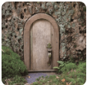  The Enchanted Woodland |  |  |  |  |  |  |  |  |  |  |  |   Moon Zoom |  |  |  |  |  |  |  | 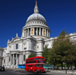  Bright Lights, Big City |  |  |  |  |  |  |  | 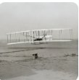  Flight Through Time |  |  |  |  |   Street Detectives
KS1 Cycle B | English pack genres
KS1 Cycle B | Book study
KS1 Cycle B | Subject-specific projects | Science |  |  | Let's explore the world  Human survival |  |  |  |  |  |  |  |  | Habitats |  |  |  |  |  |  |  |  |  |  |  | Uses of materials |  |  |  |  |  |  |  | Plant survival |  |  |  |  |  |  |  | Animal survival
KS1 Cycle B | Subject-specific projects | Art |  |  | Mixing Colours |  |  |  |  |  |  |  |  |  |  |  |  |  |  |  |  |  |  |  |  |  |  |  |  |  |  |  |  | Flower Head |  |  |  |  |  |  |  |  |  |  |  |  |  |  |  | Street View
KS1 Cycle B | Subject-specific projects | DT |  |  |  |  |  |  |  |  |  |  |  | Remarkable recipes |  |  |  |  |  |  |  |  |  |  |  | Taxi!- (Moon buggies) |  |  |  |  |  |  |  |  |  |  |  |  |  |  |  | Push and Pull
KS1 Cycle B | Subject-specific projects | RE
KS1 Cycle B | Subject-specific projects | Computing
KS1 Cycle B | Subject-specific projects | Maths
Main Focus |  |  |  |  | History |  |  |  |  |  |  | Geography |  |  |  |  |  |  |  |  |  |  |  |  |  | Geography |  |  |  |  |  |  |  | Geography |  |  |  |  |  |  |  | Science |  |  |  |  | History
Year 3/ 4 Cycle A | Driver project |  |  |  | 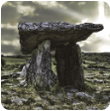  Tribal Tales |  |  |  |  |  |  | 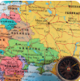  One Planet Our World |  |  |  |  |  |  |  |  |  |  |  |  |  | 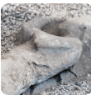  Tremors |  |  |  |  |  |  |  | 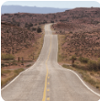  Road Trip USA |  |  |  |  |  |  |  |   Blue Abyss |  |  |  |  | 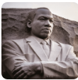  Heroes and Villains
Year 3/ 4 Cycle A | English pack genres
Year 3/ 4 Cycle A | Book study
Year 3/ 4 Cycle A | Subject-specific projects | Science |  |  | Animal Nutrition and the Skeletal System |  |  |  |  |  |  |  |  |  |  |  |  |  |  |  |  |  |  |  |  | Rocks and Soil |  |  |  |  |  |  |  | Forces and magnets |  |  |  |  |  |  |  | Plant nutrition and reproduction |  |  |  |  | Light and Shadows
Year 3/ 4 Cycle A | Subject-specific projects | Art |  |  | Prehistoric Pots |  |  |  |  |  |  |  |  |  |  |  |  |  |  |  |  |  |  |  |  | Ammonite |  |  |  |  |  |  |  |  |  |  |  |  |  |  |  | Beautiful Botanicals
Year 3/ 4 Cycle A | Subject-specific projects | DT |  |  |  |  |  |  |  |  |  | Cook Well, Eat Well |  |  |  |  |  |  |  |  |  |  |  |  |  |  |  |  |  |  |  |  |  | Making it Move |  |  |  |  |  |  |  |  |  |  |  |  |  |  |  | Greenhouse
Year 3/ 4 Cycle A | Subject-specific projects | RE
Year 3/ 4 Cycle A | Subject-specific projects | Computing
Year 3/ 4 Cycle A | Subject-specific projects | Maths
Main Focus |  |  |  |  | History |  |  |  |  |  |  | Geography |  |  |  |  |  |  |  |  |  |  |  |  |  | History |  |  |  |  | DT |  |  |  |  |  |  |  |  |  |  | Geography |  |  |  |  | Geography
Year 3/ 4 Cycle B | Driver project |  |  |  |   I am Warrior |  |  |  |  |  |  | 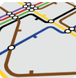  Interconnected World |  |  |  |  |  |  |  |  |  |  |  |  |  | 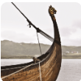  Traders and Raiders |  |  |  |  | 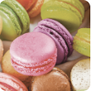  Scrumdiddlyumptious |  |  |  |  |  |  |  |  |  |  | 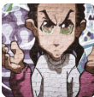  Urban Pioneers |  |  |  |  | 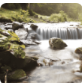  Flow
Year 3/ 4 Cycle B | English pack genres
Year 3/ 4 Cycle B | Book study
Year 3/ 4 Cycle B | Subject-specific projects | Science |  |  | Food and the Digestive System |  |  |  |  |  |  |  |  | Sound |  |  |  |  |  |  |  |  |  |  |  | Grouping and Classifying |  |  |  |  | States of Matter |  |  |  |  |  |  |  |  |  |  | Electrical Circuits and Conductors
Year 3/ 4 Cycle B | Subject-specific projects | Art |  |  | Colour Theory |  |  |  |  |  |  |  |  |  |  |  |  |  |  |  |  |  |  |  |  | Animal |  |  |  |  |  |  |  |  |  |  |  |  |  |  |  | People and Places
Year 3/ 4 Cycle B | Subject-specific projects | DT |  |  |  |  |  |  |  |  |  | Functional and Fancy Fabrics |  |  |  |  |  |  |  |  |  |  |  |  |  |  |  |  |  |  | Fresh Food, Good Food |  |  |  |  |  |  |  |  |  |  |  |  |  |  |  |  |  |  | Night Lights
Year 3/ 4 Cycle B | Subject-specific projects | RE
Year 3/ 4 Cycle B | Subject-specific projects | Computing
Year 3/ 4 Cycle B | Subject-specific projects | Maths
Main Focus |  |  |  |  | History |  |  |  |  |  |  | Science |  |  |  |  |  |  |  |  |  |  |  |  |  | Geography |  |  |  |  | History |  |  |  |  |  |  |  |  |  |  | History |  |  |  |  | Geography
Year 5/ 6 Cycle A | Driver project |  |  |  | 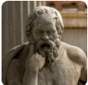  Groundbreaking Greeks |  |  |  |  |  |  | 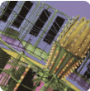  Scream Machine |  |  |  |  |  |  |  |  |  |  |  |  |  | 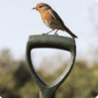  Allotment |  |  |  |  | 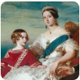  Revolution |  |  |  |  |  |  |  |  |  |  | 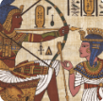  Pharaohs |  |  |  |  | 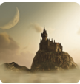  Alchemy Island
Year 5/ 6 Cycle A | English pack genres
Year 5/ 6 Cycle A | Book study
Year 5/ 6 Cycle A | Subject-specific projects | Science |  |  | Earth and Space |  |  |  |  |  |  |  |  | Forces and Mechanisms |  |  |  |  |  |  |  |  |  |  |  | Human Reproduction and Ageing |  |  |  |  |  |  |  |  |  |  |  |  |  |  |  | Properties and Changes of Materials
Year 5/ 6 Cycle A | Subject-specific projects | Art |  |  |  |  |  |  |  |  |  | Colour in Landscape |  |  |  |  |  |  |  |  |  |  |  |  |  | Expressionism/Nature's Art |  |  |  |  |  |  |  |  |  |  |  |  |  |  |  |  |  |  |  |  |  |  |  | Trailblazer, Barrier Breakers  (Mixed Media 2026)
Year 5/ 6 Cycle A | Subject-specific projects | DT |  |  | Architecture |  |  |  |  |  |  |  |  |  |  |  |  |  |  |  |  |  |  |  |  |  |  |  |  |  | Eat the Seasons |  |  |  |  |  |  |  |  |  |  | Tomb Builders
Year 5/ 6 Cycle A | Subject-specific projects | RE
Year 5/ 6 Cycle A | Subject-specific projects | Computing
Year 5/ 6 Cycle A | Subject-specific projects | Maths
Main Focus |  |  |  | Geography |  |  |  |  |  |  | History |  |  |  |  |  |  |  |  |  |  |  |  |  | Geography |  |  |  |  | History |  |  |  |  |  |  |  |  |  |  | History |  |  |  |  | Geography
Year 5/ 6 Cycle B | Driver project |  |  | 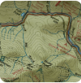  Investigating Our World |  |  |  |  |  |  | 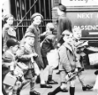  A Child's War |  |  |  |  |  |  |  |  |  |  |  |  |  | 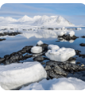Frozen Kingdoms |  |  |  |  | 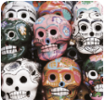  Hola Mexico! |  |  |  |  |  |  |  |  |  |  |   Peasants, Princes and Pestilence |  |  |  |  | 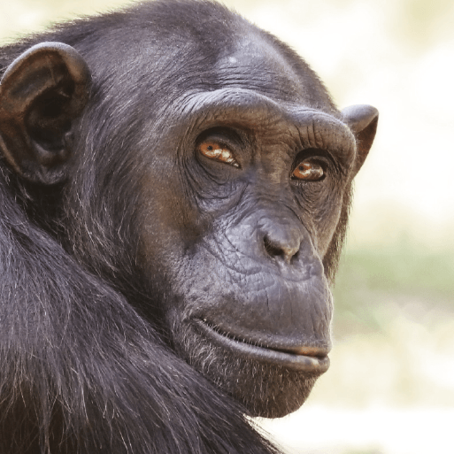  Darwins Delights
Year 5/ 6 Cycle B | English pack genres
Year 5/ 6 Cycle B | Book study
Year 5/ 6 Cycle B | Subject-specific projects | Science |  | Electrical Circuits and Components |  |  |  |  |  |  |  |  |  |  |  |  |  |  |  |  |  |  |  |  | The Circulatory System |  |  |  |  |  |  |  |  |  |  |  |  |  |  |  | Light Theory |  |  |  |  | Evolution and Inheritance
Year 5/ 6 Cycle B | Subject-specific projects | Art |  | Light, Line and Shadow |  |  |  |  |  |  |  |  |  |  |  |  |  |  |  |  |  |  |  |  | Environmental Artists |  |  |  |  |  |  |  |  |  |  |  |  |  |  |  |  |  |  |  |  |  |  |  | Bees, Beetles and Butterflies
Year 5/ 6 Cycle B | Subject-specific projects | DT |  |  |  |  |  |  |  |  | Make Do and Mend |  |  |  |  |  |  |  |  |  |  |  |  |  |  |  |  |  |  | Food For Life |  |  |  |  |  |  |  |  |  |  | Engineer
Year 5/ 6 Cycle B | Subject-specific projects | RE
Year 5/ 6 Cycle B | Subject-specific projects | Computing
Year 5/ 6 Cycle B | Subject-specific projects | Maths

