

Long Term Reading Plan (Donaldson Class)

 | Autumn Term: | Spring Term: | Summer Term:
Key Texts | 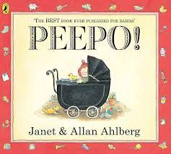  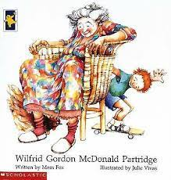  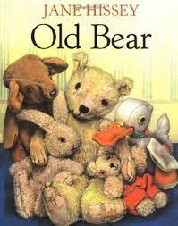  Text: | Text:  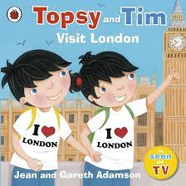  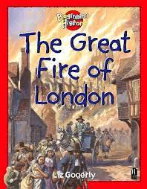  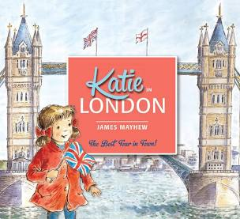  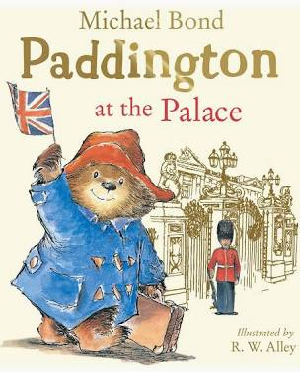 | 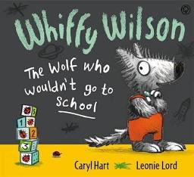  Text:  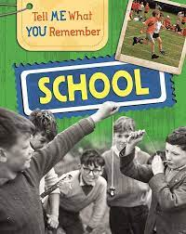  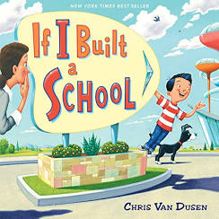
Additional Texts | Text:  The Paper Dolls  Toys and Games  The 1950s (my family remember) | Text:  The New Royal Baby  My First Book of London | Text:  Topsy and Tim start school  Miss Molly’s School of Manners  Victorians: children in. Victorian Times

Core  Reading  Skills Y1/2 Statutory requireme nts (NC) | Pupils should be taught to: Yr1  - develop pleasure in reading, motivation to read, vocabulary and understanding by:  - listening to and discussing a wide range of poems, stories and non-fiction at a level beyond that at which they can read independently  - being encouraged to link what they read or hear read to their own experiences  - becoming very familiar with key stories, fairy stories and traditional tales, retelling them and considering their particular characteristics  - recognising and joining in with predictable phrases  - learning to appreciate rhymes and poems, and to recite some by heart  - discussing word meanings, linking new meanings to those already known  - understand both the books they can already read accurately and fluently and those they listen to by:  - drawing on what they already know or on background information and vocabulary provided by the teacher  - checking that the text makes sense to them as they read and correcting inaccurate reading  - discussing the significance of the title and events  - making inferences on the basis of what is being said and done  - predicting what might happen on the basis of what has been read so far  - participate in discussion about what is read to them, taking turns and listening to what others say  - explain clearly their understanding of what is read to them.  Pupils should be taught to: Yr2  - listening to, discussing and expressing views about a wide range of contemporary and classic poetry, stories and non-fiction at a level beyond that at which they can read independently  - discussing the sequence of events in books and how items of information are related  - becoming increasingly familiar with and retelling a wider range of stories, fairy stories and traditional tales  - being introduced to non-fiction books that are structured in different ways  - recognising simple recurring literary language in stories and poetry  - discussing and clarifying the meanings of words, linking new meanings to known  - discussing their favourite words and phrases  - continuing to build up a repertoire of poems learnt by heart, appreciating these and reciting some, with appropriate intonation to make the meaning clear  - drawing on what they already know or on background information and vocabulary provided by the teacher  - checking that the text makes sense to them as they read and correcting inaccurate reading  - making inferences on the basis of what is being said and done  - answering and asking questions  - predicting what might happen on the basis of what has been read so far  - participate in discussion about books, poems and other works that are read to them and those that they can read for themselves, taking turns and listening to what others say  - explain and discuss their understanding of books, poems and other material, both those that they listen to and those that they read for themselves.

