

Long Term Reading Plan (Rosen Class)

 | Autumn Term: | Spring Term: | Summer Term:
Key Texts | Text:  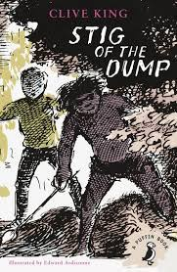  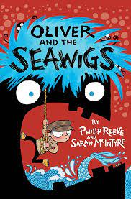 | Text:  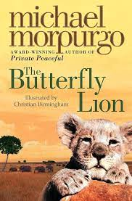  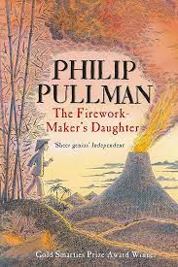 | Text:  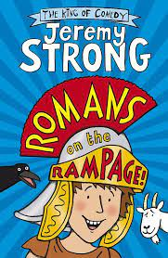  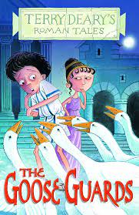
Additional Texts | Text:  Stone Age Boy  Michael Rosen Poetry  How to wash a woolly mammoth  Christmas Carol | Text:  Mary Anning Fossil Hunter  Escape from Pompeii  The secrets of Vesuvius | Text:  The Roman Adventure Boudicca’s Army
Core  Reading  Skills Y3/4 Statutory requirements (NC) | Pupils should be taught to:  - develop positive attitudes to reading and understanding of what they read by:  - listening to and discussing a wide range of fiction, poetry, plays, non-fiction and reference books or textbooks  - reading books that are structured in different ways and reading for a range of purposes  - using dictionaries to check the meaning of words that they have read  - increasing their familiarity with a wide range of books, including fairy stories, myths and legends, and retelling some of these orally  - identifying themes and conventions in a wide range of books  - preparing poems and play scripts to read aloud and to perform, showing understanding through intonation, tone, volume and action  - discussing words and phrases that capture the reader’s interest and imagination • recognising some different forms of poetry [for example, free verse, narrative poetry]  - understand what they read, in books they can read independently, by:  - checking that the text makes sense to them, discussing their understanding and explaining the meaning of words in context  - asking questions to improve their understanding of a text  - drawing inferences such as inferring characters’ feelings, thoughts and motives from their actions, and justifying inferences with evidence  - predicting what might happen from details stated and implied  - identifying main ideas drawn from more than one paragraph and summarising these  - identifying how language, structure, and presentation contribute to meaning  - retrieve and record information from non-fiction  - participate in discussion about both books that are read to them and those they can read for themselves, taking turns and listening to what others say.

