

Long Term Reading Plan (Rosen Class)

 | Autumn Term: | Spring Term: | Summer Term:
Key Texts | 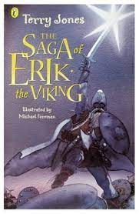  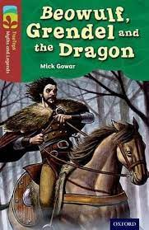  Text: | 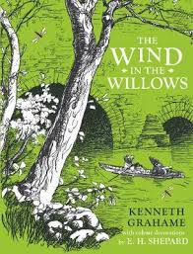  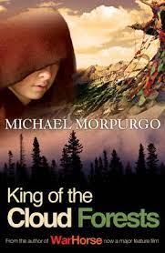  Text: | 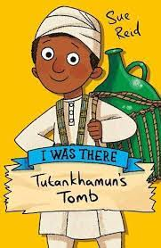  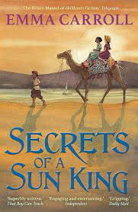  Text:
Additional Texts | Text:  How to train your dragon  Norse myth tales of Odin, Thor, and Loki  The Anglo Saxons, Vikings, and Normans: settlers and invaders of Britain | Text:  This morning I met a whale Rivers of the world Raging Rivers Mountains | Text:  Daily life in Ancient Summer  The Legend of Tutankhamun
Core  Reading  Skills Y3/4 Statutory requirements (NC) | Pupils should be taught to:  - develop positive attitudes to reading and understanding of what they read by:  - listening to and discussing a wide range of fiction, poetry, plays, non-fiction and reference books or textbooks  - reading books that are structured in different ways and reading for a range of purposes  - using dictionaries to check the meaning of words that they have read  - increasing their familiarity with a wide range of books, including fairy stories, myths and legends, and retelling some of these orally  - identifying themes and conventions in a wide range of books  - preparing poems and play scripts to read aloud and to perform, showing understanding through intonation, tone, volume and action  - discussing words and phrases that capture the reader’s interest and imagination  - recognising some different forms of poetry [for example, free verse, narrative poetry]  - understand what they read, in books they can read independently, by:  - checking that the text makes sense to them, discussing their understanding and explaining the meaning of words in context  - asking questions to improve their understanding of a text  - drawing inferences such as inferring characters’ feelings, thoughts and motives from their actions, and justifying inferences with evidence  - predicting what might happen from details stated and implied  - identifying main ideas drawn from more than one paragraph and summarising these  - identifying how language, structure, and presentation contribute to meaning  - retrieve and record information from non-fiction  - participate in discussion about both books that are read to them and those they can read for themselves, taking turns and listening to what others say.

